Genre Based Sentimental Analysis of Movies using NLP

Shruti Vangari
Department of Computer Science, University of Akron
sv47@zips.uakron.edu

Abstract

William Shakespeare said “What’s in a name? That which we call a rose by any other name would smell as sweet.” Indeed the name of a movie means a lot more than it seems. This paper proposes a new insight in the naming convention of movies. I propose and derive with the help of NLP tools that a movie is widely accepted by the audience when the name of the movie sounds positive. Also, the rating of a movie could depend on the genre. Action, romance, fantasy and comedy movies are on the hit list of the audience and critics too rate them well. Most people in general tend to stay away from horror and crime. Drama and sci-fi movies are on the hit-list of critics pulling the scores down.

1. Introduction

What kind of thoughts flash in your mind when you hear the movie’s name “Inception”? The word inception was defined as “the establishment or starting point of an institution or activity” as per the Oxford Dictionary [1]. This movie was rated 8.4 on a scale of 10 on the IMBD portal [2]. The movie’s budget was around $160 million and the total revenue to the Box Office was $292 million [2]. It is broadly classified as an action, adventure, science-fiction and thriller by genre [2].

Now, what would the name “The Shawshank Redemption” makes you think of? Although this movie’s revenue was a mere $28 million of the $25 million budget [2], the rating was 9.2 at the IMDB portal [2]. The word “redemption” is defined as “the action of saving or being saved from sin, error, or evil” [2], has also been classified as a positive word for sentimental analysis. Also, this movie was classified under the crime and drama genres’ [2]. The following table summarizes the discussion so far–

Table 1: Summary of the Movie’s Rating and Revenue
Movie | Budget | Revenue | Rating
Inception | $160 m | $292 m | 8.4/10
The Shawshank Redemption | $25 m | $28 m | 9.2/10
The following have been derived in this paper from the experiments conducted using sentimental analysis and Natural Language Processing (NLP) tools–
- A movie christened with a positive synonym or meaning makes a difference on the audience’s perception rather than a negative one. It affects the rating of the movie as well.
- The genre of the movie plays a major role in the rating and review from the viewer’s perspective.

2. NLP and Sentimental Analysis

Natural Language Processing is a field of Artificial Intelligence which deals with the interaction of human language (considered a natural language) and computers. NLP is omnipresent in its use and dates back to the time Alan Turing had proposed the famous “Turing Test” (which determined if a system was intelligent or not). The latest development from the field of NLP is the invention of the software SIRI (by Apple Inc.) and it has been accepted as a phenomenal success so far.

Sentimental Analysis (Opinion Mining) is a branch of Data mining. Using Sentimental Analysis, the polarity of a word is classified as positive or negative. For the movie reviews considered here, the analysis is performed at a clause level and is performed on the basis of the following algorithm [3].

FOR each sentence
Perform Semantic Annotation
Assign prior sentiment scores to words
Generate grammatical dependencies
Break a sentence into clauses
FOR each clause
Calculate clause level Sentiment Score (Single Aspect)
Subject or Object (Adjective + Noun)
Verb phrase (Adverb + Verb)
Predicate (Verb phase + Object/Complement)
Clause (Subject and Predicate)
Determine Aspect
END FOR
END FOR

Figure 1: Algorithm for Clause Level Sentimental Analysis
3. Movie Data in the Dataset(s) Collection

Four types of datasets were used for the analysis of the movies-

3.1. Based on Rating:

The dataset here comprised of a list of 40,000 movies which are rated on a scale of 10 (as shown in Table 1). Around 3000 votes from users were used and the formula used in calculating the rate was [1] –

Weighted rank = (v/(v+k))*X + (k/(v+k))*C

Where:

X = average for the movie (mean)
v = number of votes for the movie
k = minimum votes required to be listed
C = the mean vote across the whole report

Here in this dataset: v = 5000, k = 1000, C = 6.9.

3.2. Genre Based:

The other dataset considered was the list of movies which were classified by genre and the table below shows the total number of movies tabulated against the genre [1]:

Table 2: Number of movies based on Genre

Genre | # movies | Genre | # movies
Short | 290404 | Fantasy | 19165
Drama | 205647 | Mystery | 16616
Comedy | 157410 | Sci-Fi | 16241
Documentary | 132560 | Musical | 12904
Adult | 53789 | Western | 12746
Romance | 40938 | Biography | 12685
Action | 39828 | Sport | 11852
Animation | 37167 | History | 11367
Thriller | 34742 | War | 10748
Family | 32582 | Reality-TV | 7360
Crime | 30533 | News | 5211
Adventure | 25511 | Talk-Show | 5110
Music | 25489 | Game-Show | 3792
Horror | 24529 | Film-Noir | 495

3.3. Movie Reviews:

There was also another dataset considered where the overall review was mixed – regardless of the genre. This dataset comprised of 1000 reviews [4] which were later classified as positive or negative based on the algorithm shown in Figure 1.

3.4 Movie Names:

Another dataset which had the top 10 hits and the movies ranked in the bottom 10 were taken to prove that the name of the movie does make a significant difference. This was taken from the IMDB database too [1].

4. Experiments with NLP Tools

The tools used in this experiment are the following:

4.1. WEKA

Waikato Environment for Knowledge Analysis (WEKA), a visualization tool written in Java. It is used for data analysis [5]. The following steps were followed in processing the data –
Dataset with Rating
Dataset with Genre

Input =
Dataset with rating for a genre

WEKA

Output = Distribution classified by genre to show which gets highest rating

Figure 2: Data Processing in WEKA

The first and second datasets – with the rating and based on the Genre were passed through WEKA to analyze the distribution of which kind of movies were preferred in which particular genre.
4.2. Stanford CoreNLP

The second tool which was used was the Stanford CoreNLP, offers various ways to analyze raw English data [6]. I used this tool here to classify data as positive and negative based on the given set of words in two different files. These words were classified in two documents “positive.txt” and “negative.txt”. Each word in the input text document would be compared with the words in these files. The last two datasets – Movie Reviews and Movie Names
Input =
Movie Names Dataset
Or
Movie Reviews Dataset

Positive words file
Negative words file

Stanford CoreNLP

Output =Statistical Data
# Positive words = p
# Negative words = n
# Neutral words = nw

Figure 3: Data Processing in Stanford CoreNLP

5. Results

5.1. Using WEKA
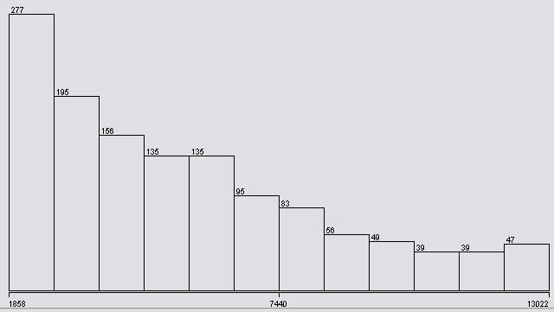
Figure 4: Data Analysis of Rated Movie Data

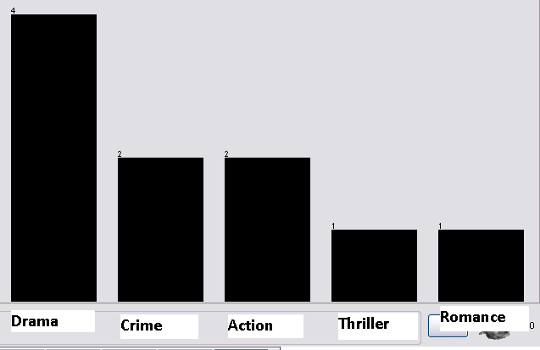
Figure 5: Analysis of movie ratings based on Genre

5.2. Using Stanford CoreNLP

5.2.1 Top 10 Movie Ratings:

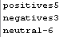
Figure 6: Data Analysis for the Top 10 Movies

5.2.2 Bottom 10 Movie Ratings:

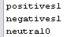
Figure 7: Data Analysis for the Bottom 10 Movies

5.3.3 All Movie Names:

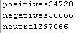
Figure 8: Data Analysis for all the Movies

6. Conclusion(s)

The data in Figure 4 reflects the various ratings given by users. The data shown in Figure 5 shows that the movies classified under the genre “Drama” got the highest ratings. Action, romance, fantasy and comedy movies are on the hit list of the audience and most critics. People in general tend to stay away from horror and crime. Drama and sci-fi movies are on the hit-list of critics pulling the scores down.

The limitations to the approach mentioned so far depends on the following –

- The Classification of the movie based on Genre

- Reliability of the positive and negative words
These limitations can also be eradicated by trying newer and different approaches to tally the results. The following two ways can also be used for the first and second limitation respectively.

The Classification of the movie based on Genre - This dataset can be explored further by experimenting with the classification of the movie based on a new type of genre. Once can classify the features in each genre as discussed in “Likability-Based Genres: Analysis and Evaluation of the Netflix Dataset” [7].

Reliability of the positive and negative words - Also, another type of classification is available in which weights are assigned to each word – positive or negative as shown in the paper in [8]. The word evaluation is mentioned.

7. References

[1] Oxford Dictionary http://oxforddictionaries.com
[2] Internet Movie Data Base http://www.imdb.com

[3] Tun Thura Thet, Jin-Cheon Na, Christopher S.G. Khoo, and Subbaraj Shakthikumar. 2009. Sentiment analysis of movie reviews on discussion boards using a linguistic approach. In Proceeding of the 1st international CIKM workshop on Topic-sentiment analysis for mass opinion (TSA '09). ACM, New York, NY, USA, 81-84. DOI=10.1145/1651461.1651476 http://doi.acm.org/10.1145/1651461.1651476

[4] Cornell Movie Review Data - 1000 positive and 1000 negative processed reviews. Introduced in Pang/Lee ACL 2004: http://www.cs.cornell.edu/people/pabo/movie-review-data/

[5] WEKA Tool http://www.cs.waikato.ac.nz/ml/weka/

[6] Stanford CoreNLP Software http://nlp.stanford.edu/software/corenlp.shtml

[7] Olney, A. M. (2010). Likability-based genres: Analysis and evaluation of the netflix dataset. In S. Ohlsson & R. Catrambone (Eds.), Proceedings of the 32nd Annual Conference of the Cognitive Science Society (pp. 37-42). Austin, TX: Cognitive Science Society.

[8] Finn Årup Nielsen "A new ANEW: Evaluation of a word list for sentiment analysis in microblogs", Proceedings of the ESWC2011 Workshop on 'Making Sense of Micro posts': Big things come in small packages 718 in CEUR Workshop Proceedings: 93-98. 2011 May. http://arxiv.org/abs/1103.2903

[9] Bo Pang, Lillian Lee, and Shivakumar Vaithyanathan. 2002. Thumbs up?: sentiment classification using machine learning techniques. In Proceedings of the ACL-02 conference on Empirical methods in natural language processing - Volume 10 (EMNLP '02), Vol. 10. Association for Computational Linguistics, Stroudsburg, PA, USA, 79-86. DOI=10.3115/1118693.1118704 http://dx.doi.org/10.3115/1118693.1118704

[10] Collection of Positive and Negative words http://www.cs.uic.edu/~liub/FBS/sentiment-analysis.html

